DON’T BE A COUCH POTATO!!!

Introduction

global perspective – indvidual research 1
  - Topic: Sports and recreation
To what extent are Sports and Exercise are Important in the School Curriculum?

In the adolescence, teens formerly are packages of nonstop energy might lose interest in physical activity. Their life between studying, friends, and sometimes part-time jobs, they have a lot of interests and responsibilities changing for their time and consideration.
Teens that started out enjoying sports and exercise tend to stay active throughout their lives. So they might just need a little encouragement to keep it going during adolescence. Sports can boost self-confidence and provide opportunities for social interaction, and allow them to experience as to how they should work in team. Regular physical activity can help avoid heart disease, diabetes, and other medical problems later in life.
I chose the topic “Importance of Sports in School Curriculum “for research as I am 15 a year teenager. As we can see around the world teenagers especially, are facing problems of obesity because of cutting –off the time to give a space to physical activity. This research work will help me know the importance of exercise in life of teenagers. In schools sports are not given too much importance so I wanted to know how this factor does affect teenagers and their life.

Why should we recommened sports to schools?
Experts recommend that teens should get 60 minutes or more of adequate to vigorous physical activity each day.
There are many reasons that why sports are an important element of school curriculum as the teens and kids growing will help them be mentally healthy. MENTAL HEALTH is needed to be taken care of as physical activity contributes to a healthy state of mind. Exercise helps stimulate the release of endorphins and increase your confidence, reduces daily stress of school and anxiety. Then the HEART - An unhealthy heart pains as it pumps oxygenated blood throughout your body, which can lead to heart attack and stroke, while a healthy heart is efficient and strong, when exercised. Reducing your WEIGHT helps you cut down a risk of major diseases and are physically fit. There are many types of sporting activities like vigorous (outdoor sports – football, cricket, baseball etc.), muscle (Exercises of stretching muscles and resistance exercises) and bone strengthening (water sports and weight training).
Doctors’ Perspective is they think that the children and teens should play Physical Games (Cricket, Football) and it is a vital role in life-cycle of humans, which needs to be given importance especially during adolescence. School's which don’t make sports mandatory or neither provide, their students don’t develop efficiently from inside (their heart, brain and immune system) and outside (physically). Their students also tend to have fear in exams and are weak, which stops them taking part in activities and achieving their goals and awards.
Teachers’ think that sports should be a part of the school curriculum, as physical activity helps them be active in sporting events which creates a platform and a talent pool for the teens. Sports have great potential to offer career opportunities.
Students think sports is an integral part of the curriculum, since it has been seen that physical exercise helps students perform better in class and exams. Most of the major health diseases can be prevented through regular workout. The Heart Diseases results to building of hard structures of cholesterol called the plaque and also a result of physical inactivity. The Type 2 diabetes occurs because of high obesity rates, and lack of physical activity in teens and young adults are now being diagnosed with it. Lack of physical activity causes also bone disorders also causes severe pains and height loss and sometimes compression fractures too. Nowadays, more people die from lack of physical activity than ageing.
Global Perspective
Sports programmer in Nigerian secondary schools is currently organized at three levels. Ojeme (2002) specified the levels to be:
Instructional sports: This promotes acquisition of basic knowledge and skills in different motor activities. This programmer ensures that students in secondary schools learn basic skills. However, it appears not much has been achieved as the programmer is plagued by inadequacies of facilities, equipment and personnel. Edwards (1973) stated that good character and good behavior learned within sports context can be transferred from the school community to the society.
Intramural sports: This promotes broad-based participation in sports activities. This programmer democratizes sports participation by all students. In the schools, however, it appears that intramural sports activities. The development of intramural sports will enable majority of the students to get engage. Students who are involved in sports are constructively engaged and their attention will be diverted from deviant acts.
Extramural Sports: This provides opportunities for the most athletically talented students in the schools to excel in their chosen sports through organized sports competition. Ekeh (2002) maintained that well organized extramural sports provide certain educational values.
One of the case studies found at: http://www.shapeup.org/about/arch_news/nl1207.html

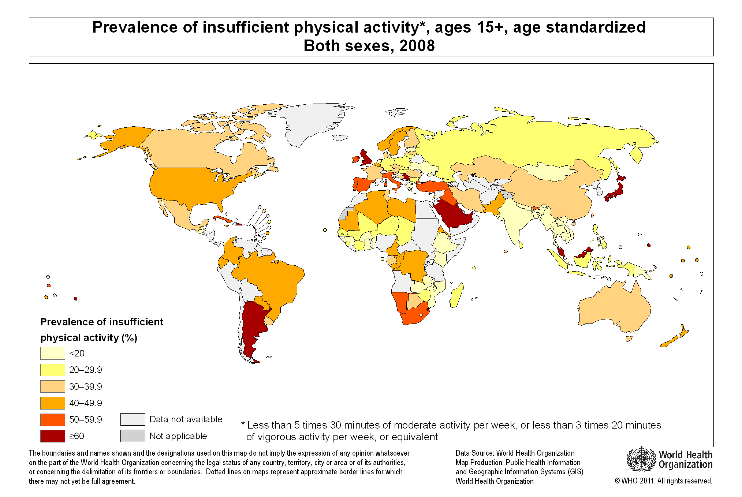
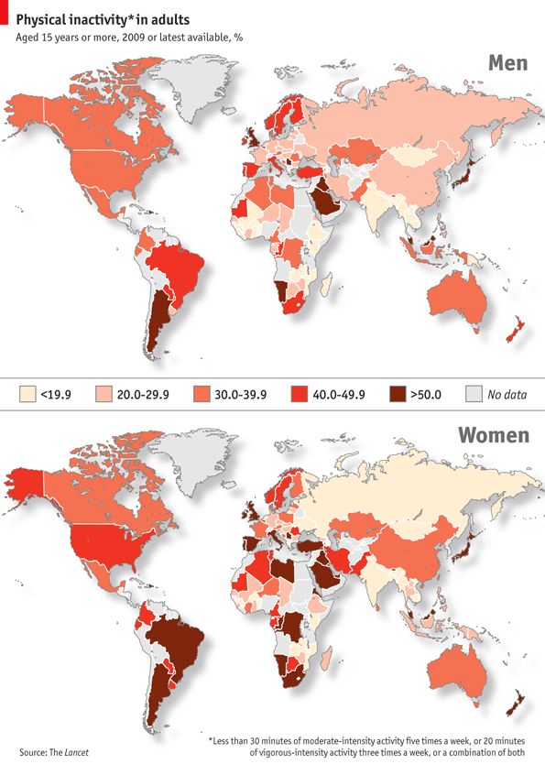
National Perspective
Haryana is a small state in North India imprinted out of joined Punjab in 1966. It has less than 2% of India’s land population.
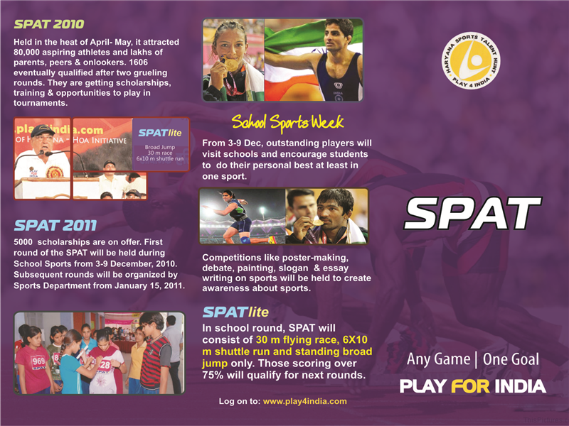
Haryana government decided to use sports as a direction to encounter their two challenges. In the early 80s, the activities began when they employed lots of coaches for various sports across the state. It was towards the turn of millennium that they looked at a focused attitude towards sports and started recognizing talented children at grass root level. The first assignment was to identify the sports to instigate and they chose the traditional sports of the state i.e. the contact sports like wrestling and boxing. Haryana being the land of Jats (traditions warriors), and the body strength was a natural fragment of their gene pool. So they startedto train young men and women in Boxing and Wrestling. These players were glowing at international level givingself-reliance to the sports department to launch a fully-fledged initiative to make Haryana the sports hub of India.

Sports Policy
In 2006, a formal 23-page sports policy was launched by the state. You can refer to it which explains the state and future actions which Haryana is going to take on sports.
haryana.gov.in/government%20Policies/sportspolicy.pdf
Methods to improve and promote sports
Every student is encouraged to take up at least one sport and is encouraged to represent India at international stage through an initiative called “Play 4 India”. Sports and Physical Aptitude test (SPAT) is directed in all the schools across the state to identify the high potential athletes in 8-14 age groups. Out of a million only 5000 children are chosen with equal no. of boys and girls that participate. They are selected on 7 physical parameters like strength, flexibility and reaction time athletes are allocated to relevant sports. These students are then supported through training, proper diet, health check-ups and they gain mental strength.
Recently a campaign was held named “NDTV-NIRMAL Mark For Sports” went arround the schools in India who enrolled their name in the competition for “India’s Fittest City”. They tested the schools with a sports brand and their employes and equipments to test the fitness and criteria were:
- The School Fitness Tests they carried out
- The campaign’s policies & facilities
- Participation in their ground events
- Self-assesment surveys
- Corporate Fitness
Obesity rates which said that one out of 4 school children in metos are obese.
Sports Infrastructure
To promote sports it requires a robust infrastructure. Around 46 nurseries have been setup across the state that provides free hostel, games kit, food and training to athletes. 171 stadiums have been setup at block level with full time coaches. Some of the district authorities, school management and parents of players collectively in a true public partnership manner manage this stadium.

INCENTIVE
Players who win medals at international events are given cash incentives along with benefits like free travel and also there is a horizontal reservation in Police jobs for performing players. About 239 sportspersons including 41 women have been enlisted under sports quota till date.

Achievements
40% of the medals at the recent commonwealth games won by India Women won about a third of these medals. Success of women athletes is encouraging parents to let their daughters choose sports as a career and they are willingly sending them to these coaching centers.
Personal Perspective:
Sports and exercise are always considered to be an important part of the life. During school time a child grows in two ways: physically and mentally. I am student and my school provides both this things in school curriculum and I understand the importance of it as it helps me grow in each and every manner and helps me to socialize, learn new things and gain knowledge from different person, it makes me grow taller, it builds me up as a whole and the most important the games which I play during my sports time helps me to work as a one team and working towards the same goal. It has always encouraged me to a new opening the same way it works in everyone else’s life. Every time the physical growth is one which also affects the mental growth and cognition process and hence physical growth is achieved by exercise and sports. It has also been proved that exercise keeps the thoughts to go in the right manner and helps children to increase their concentration; and it calms their mind.

Future Scenerios:
In schools, mostly the students would not be as active as they are now. They will probably face troubles moving a distance, in classes, in examination halls and other places. Like in class they would not be as actively participating and would develop fear in minds during examinations. We would also see the students not developing physically efficiently with a very slow growth rate, compared to students growing with regular workouts.
Locally in India, as there are governments schools with a very bad hygiene, where they don’t have good sporting facilities and don’t give a huge importance to sports. So the children and teens going to the public schools may fall sick and have illness and diseases often. They would consult a Government hospital as they don’t have a good sum of money and income at their home. So, there will be a heavy spending on government hospitals, as the government schools not promoting sports.

possible courses of action
At an individual level to solve this problem, I would like to talk to the school and encourage sports for students, would like to spread awareness by creating posters to increase awareness to stay fit. So that people take it seriously.
The local (Indian) government can fight this problem, by making more playgrounds and encourage youngsters in school to play for the Indian team by posters, banners, TV advertisement or newspapers and would request to the government to open up government gyms.
At a Global level, The United Nations can declare a world fitness day to encourage the people to stay fit! By having discounts on all the healthy products and keeping free Gym entry and exercise whole day in all the UN countries in the world, to attract people and make them stay healthy and fit. They can also release some campaigns to stay fit and healthy for people and also open Gyms which would run on a charity basis.
personal response:
So far we have seen that sports and exercise are an essential part in a student’s life. The nourishment and development of a person starts after he or she start school. The same way exercise and sports play an important role in development of a child which should necessary be included in the school curriculum. Every school is never going to consider these two aspects important, but we need to make them aware about the future consequences of which the students would face if they don’t exercise well. Thus, many of the schools have already considered these two aspects as essential items which students need to focus and work on it efficiently in order to improve their future, prevent fractures and osteoporosis which is most common due to deficiency of calcium in bones, and other diseases.

Word Count: 1991
bibliography
http://www.livestrong.com/article/459073-how-exercise-sports-is-important-in-your-lifestyle/
http://kidshealth.org/parent/nutrition_center/staying_fit/fitness_13_18.html
http://www.ncbi.nlm.nih.gov/pubmedhealth/
http://www.desai.com/innovation-applied/research/case-studies-Haryana-Sports-/tabid/260852/Default.aspx
Statistics:
http://www.lovelljohns.com/blog/index.php/2012/07/06/world-obesity-map/
http://www.bettycjung.net/Blog2011.htm
http://brucemctague.com/
Google Images

Poverty
Inequality

Introduction

global perspective – indvidual research 1
  - Topic: Poverty and inequality
What causes poverty and inequality to exist in different nations throughout the world?
I have chosen this topic because poverty is stricken everywhere and in the most parts of the world where UK was hit by recession in between which led people going penniless. As poverty has increased; the economic growth of the nations around the world has also been affected by this. Many questions come to me when I think about this topic like if the poverty increases what are the steps that the governments are taking? So I will need to know how this occurs and what actually the causes are which makes poverty and inequality to occur in most nations worldwide.
Global Perspective
Majority of the world’s and nations are in state of poverty, Why is this? Is it sufficient to blame poor people for their own predicament? Orthey have been making poor decisions, and they have been only responsible for their plight? What have been their government doing? Such causes of poverty and inequality are real. But deeper and more global causes of poverty are often less discussed.
In this face of such massive external influence, the governments of poor nations and their people are often powerless. The most commonly used threshold of low income in Britain is 60% of median household income after deducting housing costs.
Poverty is not simply about being on a low income and going without – it is also to do with being denied hood health, education, good housing and social activities, as well as basic self-esteem”
Source: Child Poverty Action Group

The distribution of income in the UK
In UK during 2008-09, the income per year before taxes and benefits of the top fifth of households was £73,800 on average compared with £5,000 for the bottom fifth, which is a ratio of 15 to one.
After taking account of taxes and benefits, the gap between the top and the bottom fifth was reduced with average income of £53,900 per year and £13,600, respectively, to a ratio of four to one.
The gap between lowest and higher income groups can be seen in this chart: 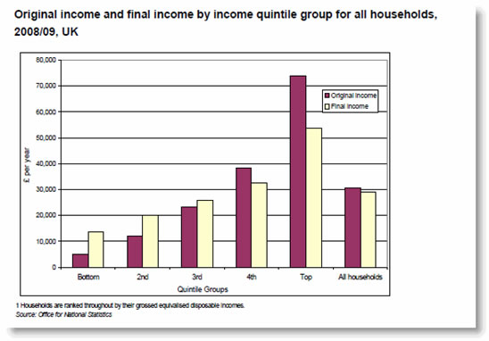
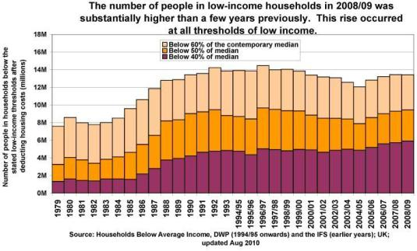
“People from poorer backgrounds are unhealthier and die earlier than the rich, according a study measuring the link between health and wealth. Poorer people in their fifties were 10 times more likely to die earlier than those who are richer, according to a report from the Institute of Fiscal Studies (IFS). The poor often have to stop work early due to ill health, the group added and this increases the risk of these groups suffering income poverty during their retirement years."
Source: BBC news and Institute for Fiscal Studies
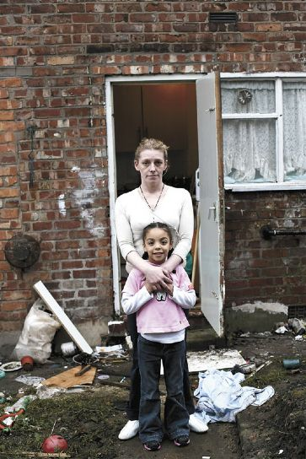 A poverty strucken area in UK

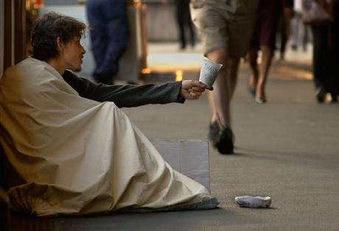
A beggar begging in streets of UK

the poverty trap

Almost half the world — over 3.1 billion people — live on less than $2.50 a day.
- The GDP (Gross Domestic Product) of the 41 Heavily Indebted Poor Countries (567 million people) is less than the wealth of the world’s 7 richest people combined.
- Nearly a billion people entered the 21st century unable to read a book or sign their names.
- Less than 1% of what the world spent every year on weapons was needed to put every child into school by the year 2000.
- 1 billion children live in poverty (1 in 2 children in the world). 640 million live without adequate shelter, 400 million have no access to safe water, and 270 million have no access to health services.
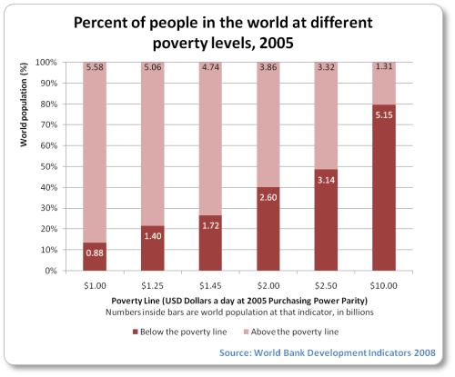
Statistics Source:
http://blogyourway.wordpress.com/2012/05/23/poverty-around-the-world-facts-numbers/

Government Policies to Reduce Poverty
When evaluating different policies to reduce poverty consider some of these related issues:
- Cost
- Effectiveness
- Impact on others in the economy
Changes to the tax and benefits system: For example, increases in higher rates of income tax would make the British tax system more progressive and reduce the post-tax incomes of people at the top of the income scale. The risk is that higher rates of taxation may act as a disincentive for people.
A switch towards greater means-tested benefits: A means-test involves a check on the financial circumstances of the benefit claimant before paying any benefit out. This would help the welfare system to target help for those households on the lowest incomes.
Special employment measures (including New Deal): Government employment schemes seek to raise employment levels and improve the employment prospects of the long-term unemployed.
Increased spending on education and training: Unemployment is a cause of poverty and structural unemployment makes the problem worse. There are millions of households in the UK where no one in the family is not working.
The National Minimum Wage: The National Minimum Wage (NMW) was introduced in April 1999 - employers cannot legally undercut the NMW.
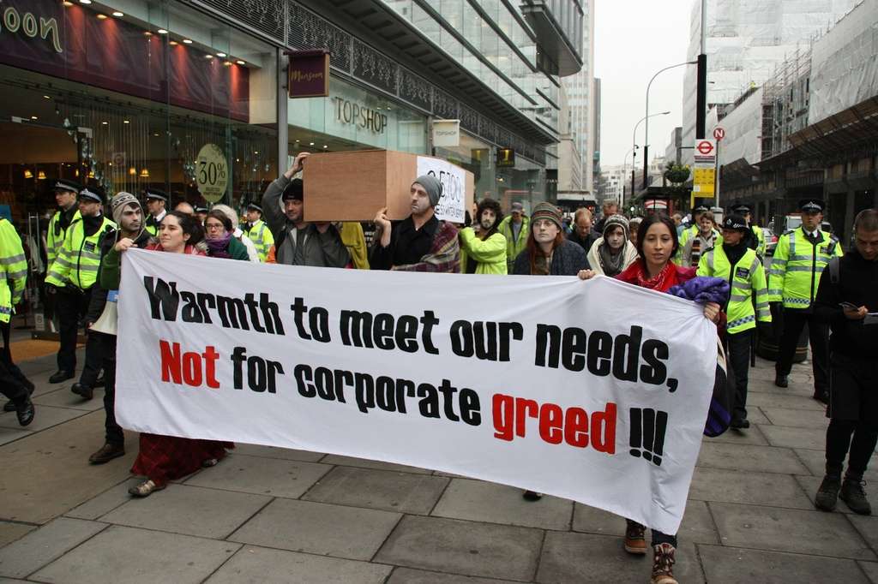
National Fuel Poverty Action by UK residents for poor people during cold winters
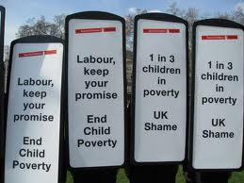
Fighting against child poverty
National Perspective
India has world’s largest number of poor people living in a single country. Out of its total population of 1.2 billion, around 350-400 million people are living below the poverty line. Nearly 75% of the poor people; are in rural areas, most of them are daily wagers, landless labourers and self-employed house holders.
- About 50% of Indians don’t have a proper shelter;
- 70% don’t have access to decent toilets (which arouses many bacteria and causes diseases);
- 35% of households don’t have a nearby water source;
- 85% of villages don’t have a secondary school (which means govt. makes much money of its 9% growth) and40% of these same villages don’t have proper roads connecting them.
Poverty in India can be classified in two categories urban and rural.
Some of the reasons for poverty in India are unequal distribution of income and the increasing population growth of India. There are large families and less resources. Increase in rural poverty causes many such problems like there is presence of malnutrition, illiteracy, diseases and long term health problems. Also there are people living in Unhygienic conditions, lack of proper housing, high infant mortality rate, and injusticeto women and social ill treatment of certain sections of society.

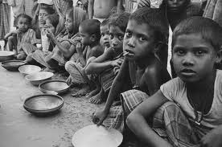
The government of the India has been trying hard to control the poverty rate in rural areas and some of the steps taken are to set up programmes like:
1. Small farmer’s development Programme.
2. Minimum needs Programme.
3. Drought area development Programme.

Urban poverty is mainly the poverty in urban areas is caused by slow job growth and improper training. There are failures of PDS system in many areas which leaves may people hungry.
These leads to problems in urban areas like there is restricted access to employment opportunities and income. People have lack of proper housing facilities, and most of them live in unhygienic environments. People have no social security schemes, and have lack of opportunity to quality health and educational services.
local perspective
Rajkot the prime city of Saurashtra has a population of 2 lakh, in whichmore than 15% people live below the poverty line.
Out of this 15% many of them commute daily either to attend government and semi-government offices, or private firms and factories. They cannot afford Rajkot’s inflated rents which have sky-rocketed even though the estate market in Rajkot from a couple of years. This has risen to such extent where a2 BHKwould be costing between `3000 and 4000 and 1BHK would be around `2000. Despitethis the fact is that hundreds of new flats are vacant - unsold, unrented.
With the rentals high, people working in Rajkot prefer to live in the nearby areas like Gondal, Virpur, Jetpur and etc. Not that only working class prefers to commute, there are those who would come for marketing - both purchase and sale, as the farmers bring their produce here to sell it at high rates in wholesale markets.
A recent and the 1st in history of the Rajkot Municipal Corporation, a survey was undertaken by the social welfare branch of the civic body in collaboration with united organization of Vadodara. It was conducted from house-to house and covered 150 backward localities and slums. It revealed that the number of families living under poverty line was 45,000 and the total people were around 1.5 lakh. It could prove to be a boon to the people living below poverty line as they may hope to get benefits under various government schemes.
Personal Perspective:
I and my family think that poverty and inequality are both interrelated and caused due to uneven distribution of good and services and a lot of corruption existing in our society where the tax not reaching the government. Corruption leads to government going with having no money where it can’t spend on poorer people and people don’t get enough resources to fulfil their basic survival needs i.e. food, clothing and shelter, and people go poor and there is inequality around where rich get richer and poor goes poorer. This cycle affects the country’s economic growth and face a lot of problems. People aren’t educated because of them having no money, and to earn it they have to work whole day having very little in hand, out of which they run their homes and feed their selves and at last they don’t have time to educate themselves.
Future Scenerios:

Poverty affecting education
There are predominant factors related to poverty for students who have a tendency to drop out from schools at very young age. It is a process that starts from primary school. These leads to many risk factors relating to poverty and education likeJuvenile delinquency, higher levels of teenage pregnancy and also the economic dependency of their low-income parents on them.
Poverty has a drastic effect on the success of students in school. Poor students are at a big disadvantage in the school at large and the classroom in particular where there are many examples of class consciousness easily spottable.
Thus it can be safely concluded that the children who live at or above the poverty line will a have successful education as compared to those who live below the poverty line. Poor children are susceptible to the flu, headaches, and infections and can also suffer from hunger and fatigue.

possible courses of action
To reduce these effects of poverty, a more permanent way is to empower the poor people produce more goods and services for themselves and for trade with others.
Poverty comes from inadequate production and/or distribution of goods and services for the needs of the people. So, the best possible manner to reduce this is to increase the production of goods and services and distribute among the right people and make poor to produce more to increase their income. To make this happen people need to be aware of the laws, rules and need to educated, organized and should have an access to the tools and the means of production.
personal response:
After completing this project and doing heavy research I came to know that there are many people who are not able to have food twice a day and they starve, and poverty is one such reason which has given rise to different crimes. I understood that we should reduce the waste of resources, and use that resource in feeding people who are poor and poverty is one such aspect which affects the economic and social growth of a particular nation. Towards this I have realised and plan to distribute books, clothes and food to the needy people. It is no point in wasting the resources hence we should learn to share in order to have equality throughout the world and make people literate so that their economic condition can improve and the crime level with corruption would reduce.
Word Count: 1892
Bibliography:
http://www.tutor2u.net/economics/revision-notes/as-marketfailure-poverty-inequality.html
http://www.globalissues.org
http://www.tradechakra.com/indian-economy/poverty-in-india.html
http://www.gdrc.org/icm/poverty-causes.htm
Google Images

