PEST ANALYSIS
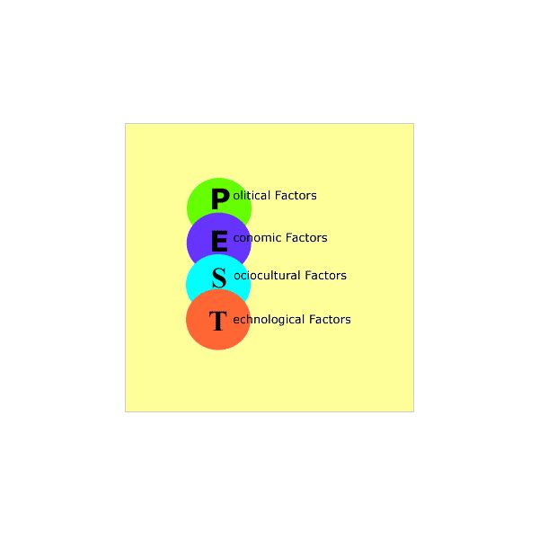
A PEST (Political, Economic, Social and Technological) analysis is a major part of the environmental scanning section of strategic management and it is used by companies during market research and strategic analysis.
Using a PEST analysis helps a business to understand various macro environmental factors that they need to take into consideration when determining the decline or growth of a particular market.

What does PEST stand for?

Political – this refers to the ways in which the government can intervene in an economy in terms of environmental and labor laws, tariffs, trade restrictions and tax policies. It also shows how a government can influence education and health and how it will affect the infrastructure of a country.

Economic – this refers to how exchange rates, inflation rates, interest rates and economic growth will impact on a business and how it can grow, develop and make various decisions. For example if a business exports goods these operations can be greatly affected by exchange rates and these are factors that need to be included in a business’s strategic management plan if they are to succeed.

Social – these factors refer to how a society behaviors culturally, how the population rate will grow, how health-conscious people in a country are, how its range is distributed in a country and the various attitudes that people have towards their careers. When social trends change it can greatly affect the need for a business’s products or services. Similarly if a society has an older population the cost of labor will increase and a business will need to change their management strategies in order to cope with these changes.

Technological – this refers to how technology can change and looks at automation, R&D activity and technological incentives that are available. Technology can also have a great impact on efficient production levels and influence decisions on outsourcing. In addition to this there are some changes in technology that can affect the costs that a business needs to meet and can improve the quality of a product or service that a business offers.

Textile Industry in India:
The textile industry is mainly a labor intensive industry as it provides livelihood to the huge population, mainly consists of unskilled workers, and thus plays a pivotal role in the development of any economy. As this particular industry also comes under the basic necessities of human beings, it impacts a lot to the society as a whole.
There has been increase in demand of textile products in last few decades globally, mainly due to rapidly changing social and economic structure of the countries worldwide. In past few years, especially after the removal the trade related tariffs and non tariff barriers in 2005, Asian countries such as India, China, Hongkong and Japan have emerged as major players in this particular industry,
Indian textile industry contributes about 14% to industrial production, 4% to the country's gross domestic product (GDP) and 16.63% to export earnings. Nearly 40% of the textiles produced in the country is exported and the textiles sector is the biggest employment generator after agriculture. The sector is expected to generate 12 million new jobs by 2012. The sector targets US$ 6 billion foreign direct investment (FDI) by 2015 to be invested in green field units in textiles machinery, fabric and garment manufacturing, as well as technical textiles.
India has made inroads into the markets of its key competitors which include Asian countries such as Sri Lanka, Bangladesh, Vietnam and Cambodia. The Indian textile and apparel industry is taking a new course by entering the Chinese market. Most of the top global apparel retailers, such as JC Penny, Nautica, Docker and Target, have their sourcing network in India. Indian textiles and apparel exports, which is worth US$ 22 billion, is expected to register a four-fold increase to touch US$ 90 to 100 billion in the next 25 years.
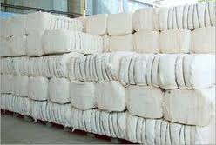

PEST ANALYSIS OF TEXTILE INDUSTRY
IN INDIA

• Political (Legal) Aspects:
An Industry will not be able to gain success, good reputation and trust if it will not consider legal and political sector as part of their strategy. Political and legal sectors include the needs of the company to follow the given policies and regulations of the government in order to be considered as legal and authorized business company. In this manner, industry should be able to consider political and legal aspects so as to show that they value the policies and regulations of the government in any of the business operations.
- Tax policy
- Employment laws
- Political stability
- Environmental regulations
- Trade and tariff restrictions
• Economic Aspects:
It is important that apparel must also give enough attention to its economic stability. The economic goal of a certain industry is like an axis in which other objectives or goals are revolving. The economic factor involves the context in which an industry belongs, i.e. the configuration of the competition in which a company operates the active demand of the products, general economic condition of the nation or region, conditions in relation with other industries, and the situation of the resource markets.
- Economic stability
- Economic growth
- Interest rates
- Inflation rates
- Exchange rates
• Socio-cultural Sector:
Society and culture is an important factor that must be given emphasis by any business, specifically those who are operating in the global arena. It is important that the company must operate in compliance with the social systems in order to gain good reputation and effective public image. On the other hand, cultural aspects is equally essential, in order to understand the various needs of different individuals that belongs to different cultures.
- Population growth rate
- Age distribution
- Career attitudes
- Consumer behavior
- Religion and culture itself
• Technological Aspects
The complexities of achieving business success through increased efficiency, effectiveness and competitiveness, combined with innovative applications of modern technology, has heightened the awareness of both technology and business managers towards more strategically oriented approaches for planning and management of any industry. Hence, it is important that industry must be able to give consideration to the technological aspects.
- Distribution and communication channels
- Technology incentives
- Automation
- Rate of technological change
- Environmental and ecological aspect
- Barriers to entry
- Production level
- Outsourcing decisions

Conclusion:
Political stability.
Govt. should apply sustainable policies for the beneficial of the Industry. Government Initiatives:
Government has taken the following initiatives to uplift the Textile Segment:
1. The Government has announced the release of a subsidy of US$ 533.87 million for the textile industry under the Technology Up-gradation Fund scheme (TUFs).
2. The government extends 10% capital subsidy and 5% interest subsidy on installation of machineries and for processing machinery under the TUFS.
3. A 41-member Working Group has also been announced to be set up with a National Fiber Policy, to ensure self-sufficiency in fiber consumption and export requirements in India.

Economic situation:
The economic condition of world can also affect the industry as increasing inflation rate make the cost of production high and thus reduce the profit margin of the industry.
Social situation:
The change in the lifestyle of the people affects the growing demand of the apparels. The change in the lifestyle and needs in different demographics also affect the demand of the customers.

Technological factor:
Technological advancement in all the sectors of the country has changed the entire socio-economic environment. Especially in the textile sector there is a lot of technological development.

